**9.Arduino UNO platform ------- servo_ultrasonic_avoid**

1. **Preparation**

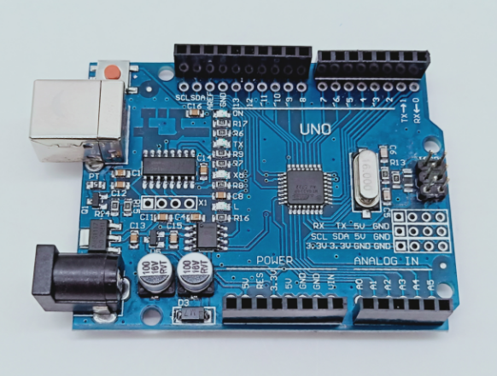

1-1 Arduino UNO board

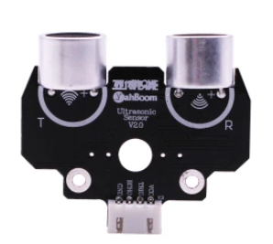 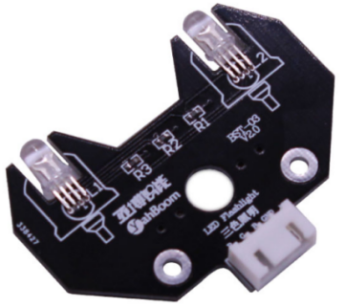

1-2 Ultrasonic module 1-3 RGB module

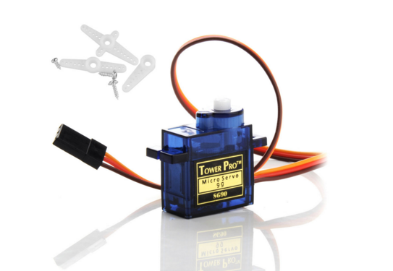

1-4 SG90 servo

**2)Purpose of Experimental**

After the code upload is completed,you need to press the K2 to start the car, and the ultrasonic obstacle avoidance with servo function is started.

When the distance on the front is less than 35cm, the colorful light module is red, then servo turn to 0 degree, ranging and recording, servo turn to 180 degree, ranging and recording, servo turn to 90 degree, ranging and recording. And the robot car will compare the left and right distance to determine whether to avoid the obstacle to the left or right. When the distance in three directions is less than 25, the robot car will turn round.

**3)Principle of experimental**

The working principle of the servo: the control signal enters the signal modulation chip from the channel of the receiver to obtain the bias voltage of the DC. It has a reference circuit inside, which generates a reference signal with a period of 20ms and a width of 1.5ms. It will compares the DC bias voltage with the voltage of the potentiometer to obtain a voltage difference and output. The positive and negative of the voltage difference is outputted to the motor drive chip to determine the forward and reverse of the motor.

Servo rotation angle is by adjusting the duty ratios of PWM (pulse width modulation) signal. The standard PWM (pulse width modulation) signal has a fixed period of 20ms (50Hz). Theoretically, pulse width distribution should be between 1 ms to 2 ms, but in fact between pulse width can be 0.5 ms and 2.5 ms. Pulse width and the servo rotation angle 0°～180° corresponds, as shown below.

0.5ms-----------------0°

1.0ms-----------------45°

1.5ms-----------------90°

2.0ms-----------------135°

2.5ms-----------------180°

**4)Experimental Steps**

4-1 About the schematic

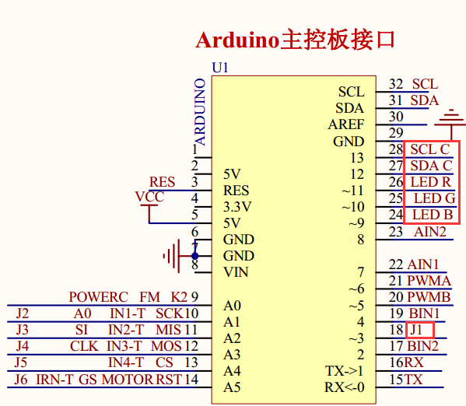

4-1 Arduino UNO interface circuit diagram

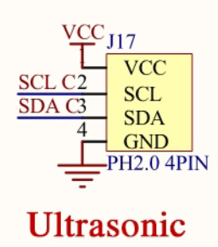

4-2 ultrasonic interface

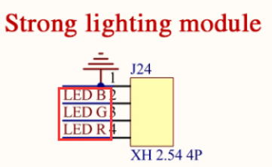 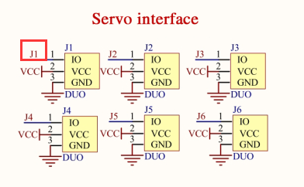

4-3 RGB module interface 4-4 Servo interface

4-2 According to the circuit schematic:

LED_R-----11(Arduino UNO)

LED_G-----10(Arduino UNO)

LED_B-----9(Arduino UNO)

J1---3(Arduino UNO)

Trig-----SCL----- 13(Arduino UNO)

Echo-----SDA-----12(Arduino UNO)

4-3 About the code

1. We need to open the code of this experiment:**servo_ultrasonic_avoid.ino**, click“**√**” under the menu bar to compile the code, and wait for the word "**Done compiling** " in the lower right corner, as shown in the figure below.

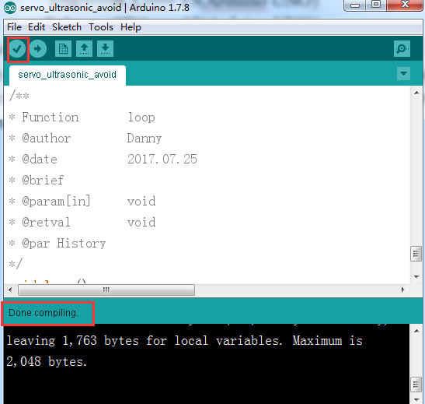

2.In the menu bar of Arduino IDE, we need to select 【Tools】---【Port】--- selecting the port that the serial number displayed by the device manager just now, as shown in the figure below.

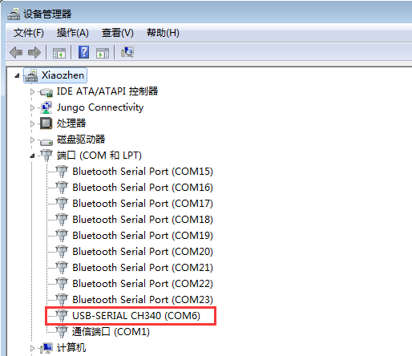

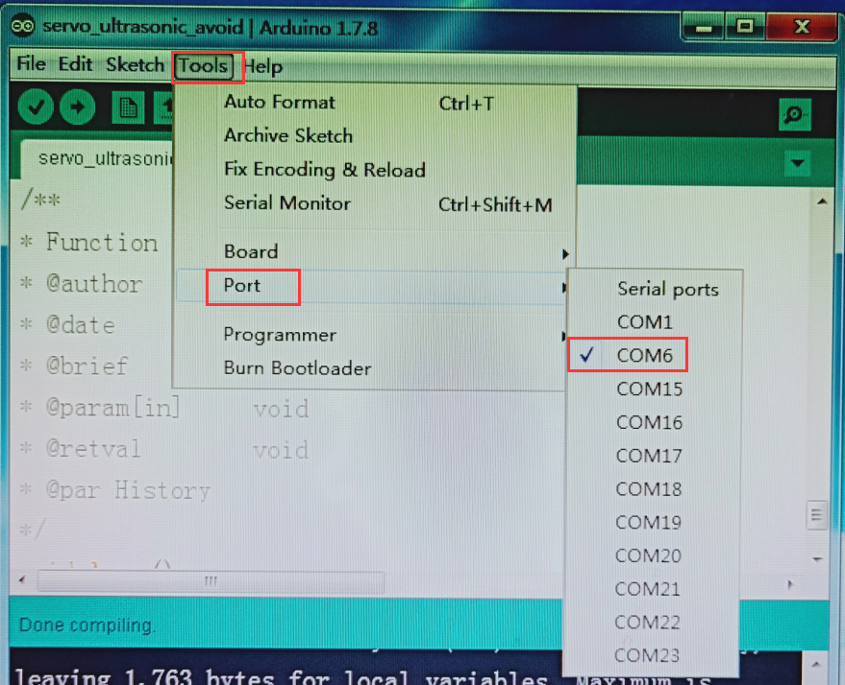

3.After the selection is completed, you need to click “**→**”under the menu bar to upload the code to the Arduino UNO board. When the word “**Done uploading**” appears in the lower left corner, the code has been successfully uploaded to the Arduino UNO board, as shown in the figure below.

